Integrating Hydro-Meteorological Data and Urban Factors for flood prediction in Mexico City
Luis Daniel Rivera Salinas¹[0009-0007-0938-9170], Olimpia Helena García Huerta²[0009-0002-9103-5542] and David Rodriguez Fragoso³[0009-0008-5660-8783]
¹ Tecnológico de Monterrey, Atizapán de Zaragoza MX 52926, MEX
Abstract. Flood prediction in Mexico City has emerged as a critical challenge due to the interaction of climatic, hydrological, urban, and infrastructural factors that increase territorial exposure and vulnerability. Current emergency management practices remain reactive, relying on citizen reports to guide response and maintenance actions, which often results in delayed intervention, economic losses, traffic disruption, and inefficient allocation of resources. Prior research has addressed this problem through multiple perspectives, including land-use and runoff-based hydrological vulnerability assessments, spatial flood susceptibility models, hydrological-hydraulic simulations, institutional risk atlases, and nature-based solutions. Collectively, these studies demonstrate that flood risk in the Valley of Mexico depends not only on precipitation intensity, but also on infiltration loss, urban expansion, topography, drainage performance, land-use change, subsidence, and basin degradation.
Despite these contributions, important limitations remain. Much of the existing literature emphasizes risk assessment and scenario simulation rather than operational prediction, while several approaches rely on return periods or synthetic rainfall, limiting their applicability to real-time forecasting and early warning. In this context, this work proposes the development of a predictive flood model for the Valley of Mexico that integrates meteorological, hydrological, territorial, and urban information within a unified framework. The proposed dataset combines temporal indicators, meteorological and soil-moisture variables, spatial and administrative descriptors, and lag-based aggregated features, enabling the representation of both current environmental conditions and antecedent hydrological dynamics. By shifting from descriptive and simulation-oriented approaches toward predictive modeling, this study seeks to support more effective urban risk management, territorial planning, and early warning systems in Mexico City.
Keywords: XGBoost, Urban Flooding, Timeseries
- Problem Statement
The prediction in Mexico City has become a priority due to the combination of physical, urban, and climatic factors that increase the territory's exposure and vulnerability, along with an aging infrastructure that receives little to no maintenance at all.

Currently, the city’s emergency response and management authorities operate under a reactive scheme; they rely on citizens reports, such as the SUAC system, to deploy maintenance resources. This model results in severe economic damage, intense traffic paralysis, and inefficient resource allocation to prevent or address the issue.
While advanced meteorological forecasts can predict heavy rainfall, they can't predict infrastructure failures, such as sewer blockage, poor maintenance, or failures in the drainage system. The standard weather forecast by itself can't be translated into metrics that indicate which municipalities may experience drainage collapse.
Therefore, the main problem lies in the lack of actionable, predictive systems that merge meteorological telemetry with historical infrastructure vulnerabilities. Developing a predictive model that combines meteorological data and historical system vulnerabilities is essential to shift the city's strategy from reactive to proactive disaster prevention.
- Related Work
The first line of research has focused on hydrological vulnerability associated with land-use change. Zúñiga and Pérez-Campuzano argue that the risk of flooding in Mexico City depends not only on events of intense precipitation but also on the decrease of infiltration caused by the loss of natural vegetation and urban expansion. Their study employs the Curve Number (CN) method to integrate precipitation, soil cover, and surface runoff, showing that urban growth between 1992 and 2021 increased hydrological vulnerability and flood risk, especially in the city’s western basins. A particularly relevant finding is that a degraded basin can generate approximately 90% more runoff than a non-built-up one, which reinforces the need to incorporate land use and basin state variables into predictive models.

Another important aspect concerns spatial models of urban risk. Zambrano, Pacheco-Muñoz, and Fernández developed a spatial model for Mexico City that combines geomorphological and anthropic variables, highlighting the influence of topography, landscape connectivity, land use, and subsidence on the occurrence of floods. His work shows that a significant part of the city has high susceptibility to small and large floods and also shows that the lower-income population is concentrated in areas with higher risk. This approach is relevant for predictive models because it demonstrates that the hydrometeorological variable alone is insufficient: prediction improves when incorporating spatial structural features of the territory.

The hydrological-hydraulic models form a third line. In this category stands out the work of Arosio et al., who apply EPASWMM to reconstruct rainfall floods in Mexico City from rain events with different return periods. Its model integrates runoff formation, routing in urban drainage, and estimation of flooded areas using GIS. Although its main objective was to assess direct and indirect impacts of floods using a graph-based approach, the study demonstrates the value of hydrological models to simulate the urban response to intense storms and to represent the critical role of the drainage system. Moreover, it emphasizes that subsidence and urban growth deteriorate hydraulic functionality, so any robust predictive model must consider these dynamics.

In a complementary way, the City of Mexico Risk Atlas presents an important institutional effort for the spatial characterization of threats. This work gathers geographical information on multiple hazards - including floods - and documents that flood events are concentrated in central and northern city areas. Although it is not a predictive model in the strict sense, it provides a valuable spatial basis for calibrating, validating, or fueling machine learning or physical simulation models, especially in zoning, territorial prioritization, and multicriteria analysis tasks.

Finally, another recent line of work has explored nature-based solutions (NbS) and their relationship to water flow regulation. Soto-Montes-de-Oca et al. show that peri-urban areas and upstream ecosystems can reduce costs and risks associated with flooding in Mexico City. This approach does not seek to directly predict the occurrence of floods, but it does provide explanatory variables of excellent value for modeling, such as runoff coefficients, natural coverage, water regulation, and location of demand zones affected by sinking. Its main contribution to the state of the art is to shift attention from gray infrastructure towards an integral basin-city vision.

Recently, a new paradigm that combines the usage of machine learning models (ML) along with historical data to address the limitations of physical hydraulic models. Literature shows that ensemble models, particularly Random Forest and eXtreme Gradient Boosting (XGBoost), are increasingly applied not only to urban forecasting but also for urban predictions. Unlike traditional systems that require solving complex equations on the topographical data, ML algorithms show non-linear relationships between meteorological telemetry and historical data.

Overall, the revised literature shows that there are four major approaches to studying floods in the Valle de México: hydrological vulnerability models based on land use and runoff; spatial models of susceptibility and risk; hydrological-hydraulic simulation models; and geospatial platforms and risk atlases for decision support. However, important gaps remain. First, many studies focus on assessing risk or simulating scenarios but not necessarily predicting future events with an operational approach. Second, several works use return periods and synthetic rainfall, which limits their ability to predict in real time. Third, the simultaneous integration of precipitation, topography, drainage, subsidence, land-use change, and basin degradation variables into a single predictive framework is still limited.

Therefore, the development of a model for predicting floods in the Valley of Mexico finds its justification in the need to move from descriptive or simulation approaches to predictive tools that integrate meteorological, hydrological, territorial, and urban information. Such a model could build on previous findings about infiltration, runoff, topography, subsidence, and drainage, but be specifically oriented toward anticipating areas and likely levels of flooding under conditions observed or predicted, thereby contributing to risk management, urban planning, and early warning systems.

- Proposed Work
To address the limitations of reactive flood management, this work proposes an initiative-taking, data-driven strategy that merges meteorological telemetry with historical incident data. The objective is to deploy a supervised Machine learning predictive model capable of anticipating the collapse of water infrastructure within a specific municipality. By analyzing the “hydrological memory” of the preceding 24 hours, rather than the instantaneous weather, the model can function as an early warning system, shifting from post disaster response to preemptive resource allocation.

  - Dataset description

The predictive accuracy of the model depends on capturing both physical weather and the structure of the city, measured on the incidents by municipality. Therefore, the dataset is engineered through the fusion of two different sources:

Meteorological telemetry: Using the Open-Meteo API, it provides hourly, municipality-level physical data, including but not limited to precipitation, soil moisture at different depths, and relative humidity. This data will function as the trigger variable.
Citizen Incident Reports (SUAC): The system, where all citizens can report incidents, serves as the ground truth for infrastructure failure. This will function as the responsive variable. From this data, we’ll be focusing on 3 main labels, which are “drainage maintenance (mantenimiento drenaje)”, “sewer maintenance (mantenimiento de alcantarillado)”, and “water leak (fuga de agua)”.

By merging these resources, the final dataset bridges the gap between atmospheric conditions and ground-level infrastructure. The final dataset variables can be grouped into five main categories: temporal identifiers, meteorological variables, hydrological variables, spatial and administrative descriptors, and aggregated lag features.

Temporal identifiers
- time: Timestamp associated with each observation. It defines the dataset's temporal resolution and anchors all environmental and incident-related measurements.
- mes: Month extracted from the timestamp, included to capture seasonal variation.
- dia_semana: Day of the week, useful for identifying weekly temporal patterns.
- hora_del_dia: Hour of the day, which may capture sub-daily variation in both environmental conditions and incident occurrence.
- es_fin_de_semana: Binary variable indicating whether the observation corresponds to a weekend.

Meteorological variables
- temperature_2m: Air temperature measured at 2 meters above ground level.
- precipitation: Precipitation recorded at the time of the observation.
- relative_humidity_2m: Relative humidity measured at 2 meters above ground level.
- wind_speed_10m: Wind speed measured at 10 meters above ground level.
- wind_gusts_10m: Maximum wind gust intensity measured at 10 meters.
- et0_fao_evapotranspiration: Reference evapotranspiration estimated using the FAO methodology, representing atmospheric evaporative demand.

Hydrological variables
- soil_moisture_0_to_7cm: Soil moisture content in the upper 0–7 cm soil layer.
- soil_moisture_7_to_28cm: Soil moisture content in the 7–28 cm soil layer.
- soil_moisture_28_to_100cm: Soil moisture content in the deeper 28–100 cm soil layer.

Spatial and administrative descriptors
- alcaldia: Borough or administrative division associated with observation.
- tema_solicitud: Category or thematic classification of the reported request or incident.
- severidad: Severity level assigned to the incident or request.
- incident: Incident indicator or response variable, representing the occurrence of the event of interest.

Aggregated lag-based features
These variables summarize recent environmental conditions and are intended to capture short- and medium-term accumulation effects.

Precipitation aggregates
- precipitation_sum_3h: Cumulative precipitation over the previous 3 hours.
- precipitation_sum_6h: Cumulative precipitation over the previous 6 hours.
- precipitation_sum_12h: Cumulative precipitation over the previous 12 hours.
- precipitation_sum_24h: Cumulative precipitation over the previous 24 hours.

Shallow soil moisture averages
- soil_moisture_0_to_7cm_mean_3h: Mean shallow soil moisture over the previous 3 hours.
- soil_moisture_0_to_7cm_mean_6h: Mean shallow soil moisture over the previous 6 hours.
- soil_moisture_0_to_7cm_mean_12h: Mean shallow soil moisture over the previous 12 hours.
- soil_moisture_0_to_7cm_mean_24h: Mean shallow soil moisture over the previous 24 hours.

Intermediate soil moisture averages
- soil_moisture_7_to_28cm_mean_3h: Mean soil moisture at 7–28 cm over the previous 3 hours.
- soil_moisture_7_to_28cm_mean_6h: Mean soil moisture at 7–28 cm over the previous 6 hours.
- soil_moisture_7_to_28cm_mean_12h: Mean soil moisture at 7–28 cm over the previous 12 hours.
- soil_moisture_7_to_28cm_mean_24h: Mean soil moisture at 7–28 cm over the previous 24 hours.

Relative humidity averages
- relative_humidity_2m_mean_3h: Mean relative humidity over the previous 3 hours.
- relative_humidity_2m_mean_6h: Mean relative humidity over the previous 6 hours.
- relative_humidity_2m_mean_12h: Mean relative humidity over the previous 12 hours.
- relative_humidity_2m_mean_24h: Mean relative humidity over the previous 24 hours.
- Experiments and Results
  - Experimental Setup
To evaluate the proposed approach, we implemented a supervised learning pipeline using historical flooding data. Given the temporal nature of the problem, a time-aware validation strategy was adopted to ensure that past data is used to predict future events, avoiding data leakage.

The model selected for this task was XGBoost due to its strong performance on structured data and its ability to model non-linear relationships.

The main configuration parameters include:

- eval_metric = logloss, which measures the error after each boosting iteration and guides the optimization of probabilistic predictions
- tree_method = hist, which accelerates training by grouping feature values into histograms instead of evaluating all possible splits

To properly evaluate model performance under temporal constraints, TimeSeriesSplit was used. This approach trains the model on progressively larger windows and validates it on future data, closely simulating real-world deployment.

Given the imbalanced nature of the dataset, the evaluation focuses on average precision (PR-AUC), which captures the trade-off between precision and recall more effectively than accuracy.
  - Baseline performance
The baseline model was trained using default hyperparameters and evaluated on the test set using the standard classification threshold of 0.5.

Class | Precision | Recall | F1 | Support
0 | 0.79 | 0.87 | 0.82 | 105,203
1(Flood) | 0.71 | 0.58 | 0.64 | 58,954

Table 1. Baseline model performance on the 2025 test set.
As shown in Table 1, the model achieves an overall accuracy of 0.76. However, performance in the positive class (flood events) is significantly lower, with a recall of 0.58. This indicates that a substantial number of flood events are not detected.

Although the model achieves a relatively high precision of 0.71, the imbalance between precision and recall suggests a bias toward the majority class. This behavior is expected in imbalanced datasets and highlights the need for further adjustments.
  - Hyperparameter Tuning
To further improve performance, hyperparameter optimization was performed using a randomized search strategy combined with temporal cross-validation.

Hyperparameter | Value
learning_rate | 0.2
colsample_bytree | 0.9
max_depth | 9
min_child_weight | 7
subsample | 0.7
tree_method | hist

Table 2. Selected hyperparameters after tuning.

The selected hyperparameters include a maximum tree depth of 9, allowing the model to capture complex patterns, and a minimum child weight of 7, which helps prevent overfitting. Additionally, a column sampling rate of 0.9 was used to introduce randomness and improve generalization.

The use of histogram-based tree construction (tree_method = hist) also contributed to efficient training without sacrificing performance.
  - Threshold Adjustment
To improve the detection of flood events, the classification threshold was adjusted from the default value of 0.5 to 0.40. This modification allows the model to classify more instances as positive, increasing sensitivity to flood events.

Threshold | Precision | Recall | F1 | Accuracy
0.50 | 0.71 | 0.58 | 0.64 | 0.76
0.40 | 0.66 | 0.69 | 0.67 | 0.76
Table 3. Impact of threshold adjustment on classification performance.

As shown in Table 3, lowering the threshold from 0.50 to 0.40 significantly improves recall from 0.58 to 0.69, increasing the number of correctly identified flood events. Although precision decreases slightly, the trade-off is acceptable given the objective of minimizing missed flood events.
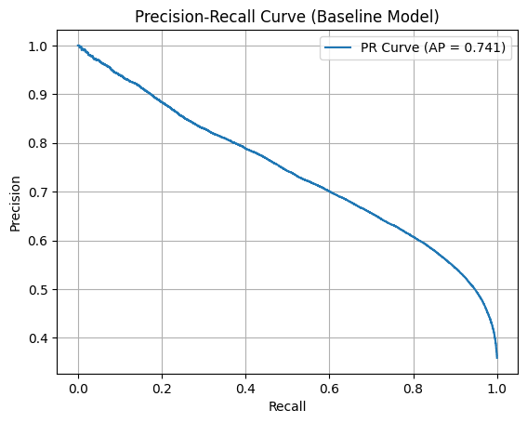
Fig. 1. Precision-Recall curve of the baseline model.

Figure 1 illustrates the trade-off between precision and recall across different thresholds. This curve supports the decision to lower the threshold, as it highlights regions where recall can be improved with an acceptable decrease in precision.
  - Final Model Evaluation
The final model, incorporating both threshold optimization and hyperparameter tuning, was evaluated on the test set.

Model | Threshold | Precision | Recall | F1 | Accuracy
Baseline | 0.50 | 0.71 | 0.58 | 0.64 | 0.76
Baseline+Threshold | 0.40 | 0.66 | 0.69 | 0.67 | 0.76
Final tuned model | 0.40 | 0.66 | 0.72 | 0.69 | 0.77

Table 4. Performance comparison between baseline and final tuned model.

The results show a clear improvement over the baseline, particularly in recall, which increases to 0.72. This confirms that the model is more effective at detecting flood events.

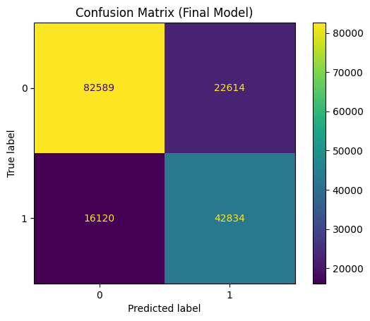
Fig. 2. Confusion matrix of the final model.

The confusion matrix shows a reduction in false negatives compared to the baseline model, which is a key objective in this application. This reduction directly improves the model’s ability to detect flood events in real-world scenarios, which is critical for early warning systems.

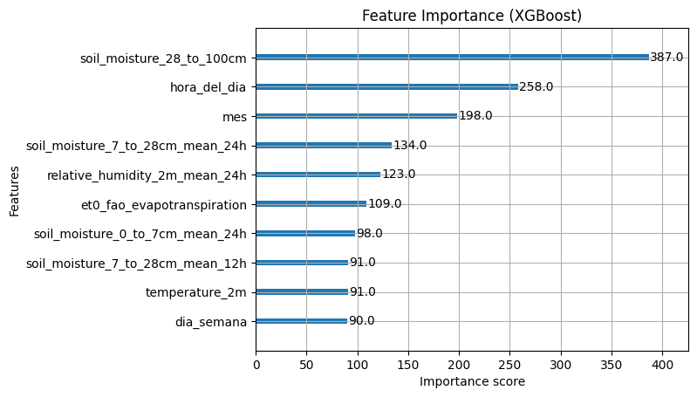
Fig. 3. Feature importance based on the XGBoost model.

Feature importance analysis provides insight into which variables contribute most to the model’s predictions, improving interpretability and supporting further analysis. The most important features are related to soil moisture and temporal variables, which align with hydrological expectations and support the validity of the model.
  - Discussion
The experimental results highlight several key insights. First, temporal validation is essential to avoid overly optimistic results caused by data leakage. Second, optimizing PR-AUC instead of accuracy leads to better performance in imbalanced scenarios.

Additionally, threshold optimization proved to be a simple yet highly effective technique to improve recall. Finally, the combination of hyperparameter tuning and model adjustments resulted in a more robust and practical predictive model.

Overall, the proposed approach demonstrates that aligning model design decisions with the characteristics of the problem leads to meaningful improvements in performance.
- Conclusions
In conclusion, this study demonstrates that flood event prediction in Mexico City requires moving beyond reactive management and descriptive simulation-based analysis toward predictive approaches that integrate the multiple drivers of urban flood risk.
As shown in the literature review, precipitation alone is insufficient to explain flood occurrence, since the Valley of Mexico is also shaped by land-use change, infiltration loss, topography, and other factors that significantly influence the runoff dynamics of water flow.
Building on these insights, this study proposed a predictive framework that combines meteorological, hydrological, temporal, and spatial information within a unified model.

The results show that this integration is effective. The final model improved upon the baseline by increasing F-1 score and recall, while reducing false negatives. This improvement is especially important in situations where missed events can cause serious damage and potential loss of life. Taken together, these findings suggest that the proposed approach provides a meaningful contribution to both literature and practice, offering a practical foundation for future early warning, urban planning and risk management systems in Mexico City
  - Future work
While the proposed XGBoost architecture successfully establishes a strong baseline for predictive flood management using meteorological telemetry, the experimental results suggest that relying only on meteorological and incident data introduces a performance ceiling. To evolve this framework into a more effective early warning system, future research should focus on the following directions:
- Integration of spatial and topographic data, enabling the model to account for terrain variability. This would allow it to distinguish, for example, between heavy rainfall occurring on steep slopes and the same rainfall over flat or low-lying areas prone to water accumulation.
- Incorporation of infrastructure-related metadata, such as pipe diameter, network age, and construction materials. Including these features would help the model differentiate between flooding caused by excessive hydraulic load and flooding driven by structural deficiencies in the drainage system.
- Exploration of deep learning approaches, which could better capture complex interactions among meteorological, hydrological, and urban variables, potentially improving the model’s ability to anticipate flood events more accurately.

References
- Arosio, M., Martina, M. L. V., Creaco, E., & Figueiredo, R. (2020). Indirect Impact Assessment of pluvial flooding in urban areas using a Graph-Based Approach: the Mexico City Case Study. Water, 12(6), 1753. https://doi.org/10.3390/w12061753
- Locatel. (2026). Tablero de Solicitudes: Sistema Unificado de Atención Ciudadana [Dataset]. In Tablero 311. https://tablero311.cdmx.gob.mx/#
- Martínez, M. G., Berthet, L. J. O., Estrada, J. M., & Castro, O. C. (2025). Identification of flood-prone areas using the HEC-RAS 2D model in a region of the Valley of Mexico. Chemosphere, 386, 144609. https://doi.org/10.1016/j.chemosphere.2025.144609
- Novelo-Casanova, D. A., Suárez, G., Cabral-Cano, E., Fernández-Torres, E. A., Fuentes-Mariles, O. A., Havazli, E., Jaimes, M. Á., López-Espinoza, E. D., Pozzo, A. L. M., Morales-Barrera, W. V., Morales-Rodríguez, H. L., Nieto-Torres, A., Rodríguez-Elizarrarás, S. R., Solano-Rojas, D., & Velasco-Herrera, V. M. (2021). The Risk Atlas of Mexico City, Mexico: a tool for decision-making and disaster prevention. Natural Hazards, 111(1), 411–437. https://doi.org/10.1007/s11069-021-05059-z
- Soto-Montes-De-Oca, G., Cruz-Bello, G. M., & Bark, R. H. (2023). Enhancing megacities’ resilience to flood hazard through peri-urban nature-based solutions: Evidence from Mexico City. Cities, 143, 104571. https://doi.org/10.1016/j.cities.2023.104571

Appendix A. Code Availability
The implementation of the proposed model, along with the datasets, preprocessing pipeline, and evaluation scripts used in this study, is publicly available at:
https://github.com/eldeivid420/TC6004.550---Equipo7

The repository also includes the full documentation of the project and a copy of this paper for reproducibility purposes.

